E-Commerce Sales Analysis & Business Insights

Project Objective:
The primary objective of this project is to analyze e-commerce sales data and identify meaningful patterns and trends in business performance. The analysis focuses on key factors such as sales revenue, product performance, quantity sold, pricing, discounts, customer behavior, and sales trends over time.
The project aims to understand what is happening in the business, why certain sales patterns occur, what trends may continue in the future, and what actions can be taken to improve performance. Through this analysis, important factors influencing sales and revenue can be identified, along with areas that require attention or improvement.
The project applies the four fundamental types of data analysis — Descriptive, Diagnostic, Predictive, and Prescriptive Analysis — to transform raw e-commerce data into clear, actionable business insights that can support better decision-making, improve sales performance, and contribute to overall business growth.

Dataset Description:
The E-Commerce Sales Dataset contains transactional sales data covering customers, products, sales quantities, unit prices, discounts, and total sales amounts. The dataset is organized into different dimensions, such as Sales, Product, and Customer details. It can be used to analyze sales performance, product trends, customer behavior, discounts, and revenue patterns.

Column Description:

Column Name | Description
Month | Provides Month of the order given
Year | Provides the Year of the order given
Customer ID | Provides the Unique id given to each customer
Gender | Provides the Gender of the customer
Loyalty Level | Provides the Loyalty type of the customer
Product ID | Provides the Unique id given to each product
Category | Provides the Category of the Product
Sub Category | Provides the Sub Category of the product
Store ID | Provides the Unique id given to each Store
Region | Provides the Region of the store where it is located
City | Provides the City of the store where it is located
Store Type | Provides the Type of store
Quantity | Provides the Quantity of products sold
Unit Price | Provides the unit prices of each product
Discount | Provides the Discount given to Customer
Payment Type | Provides the Type of payment used
Revenue | Provides the Total amount or revenue produced for each Sale id

Data cleaning & transformation:

Formula used:

Converting the Raw Data into Table

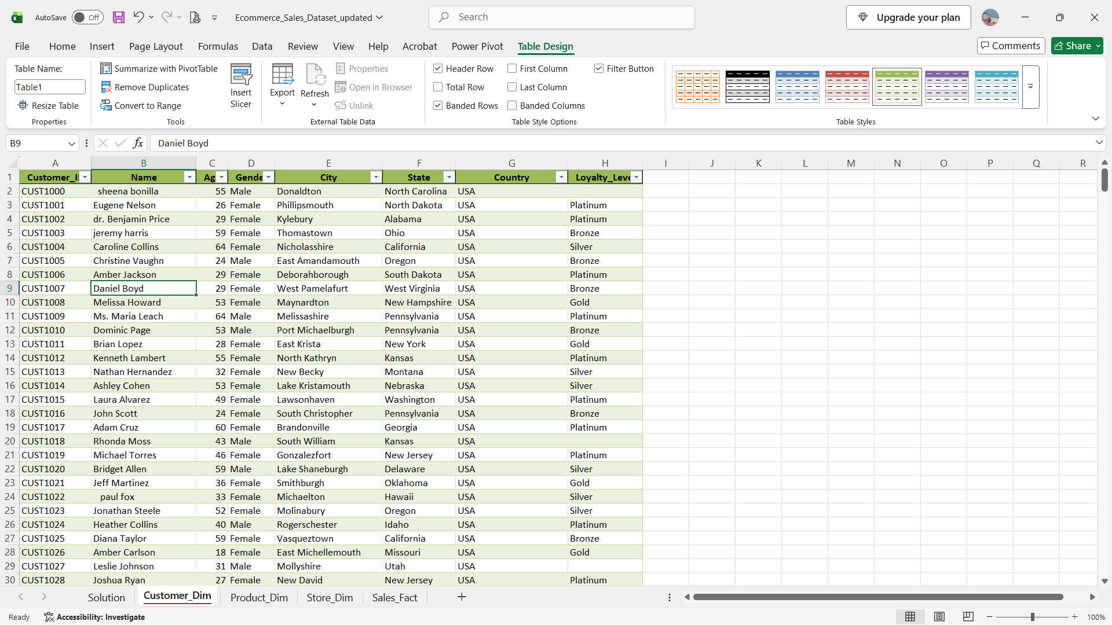

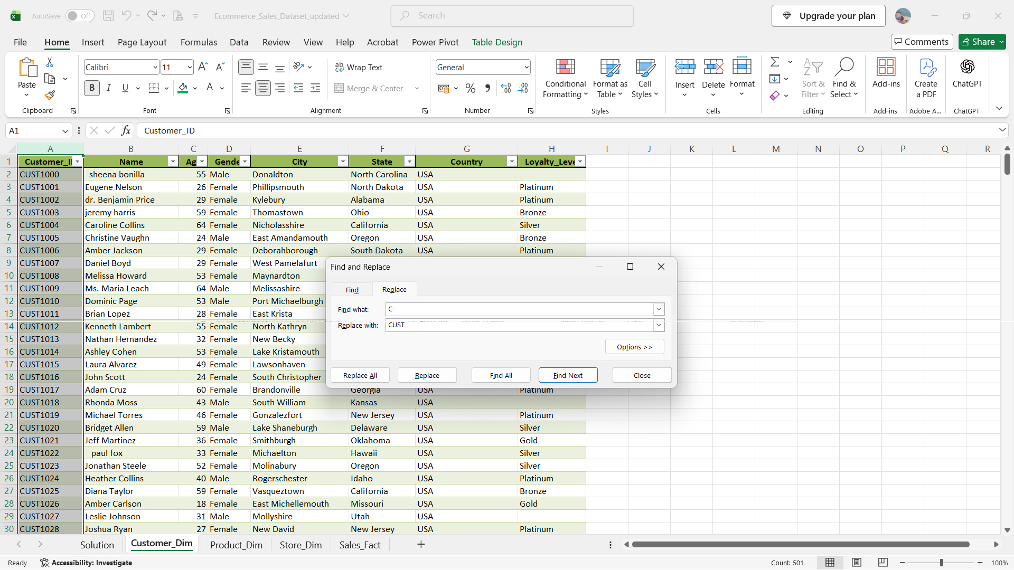
=PROPER(TRIM(CLEAN([@Name])))

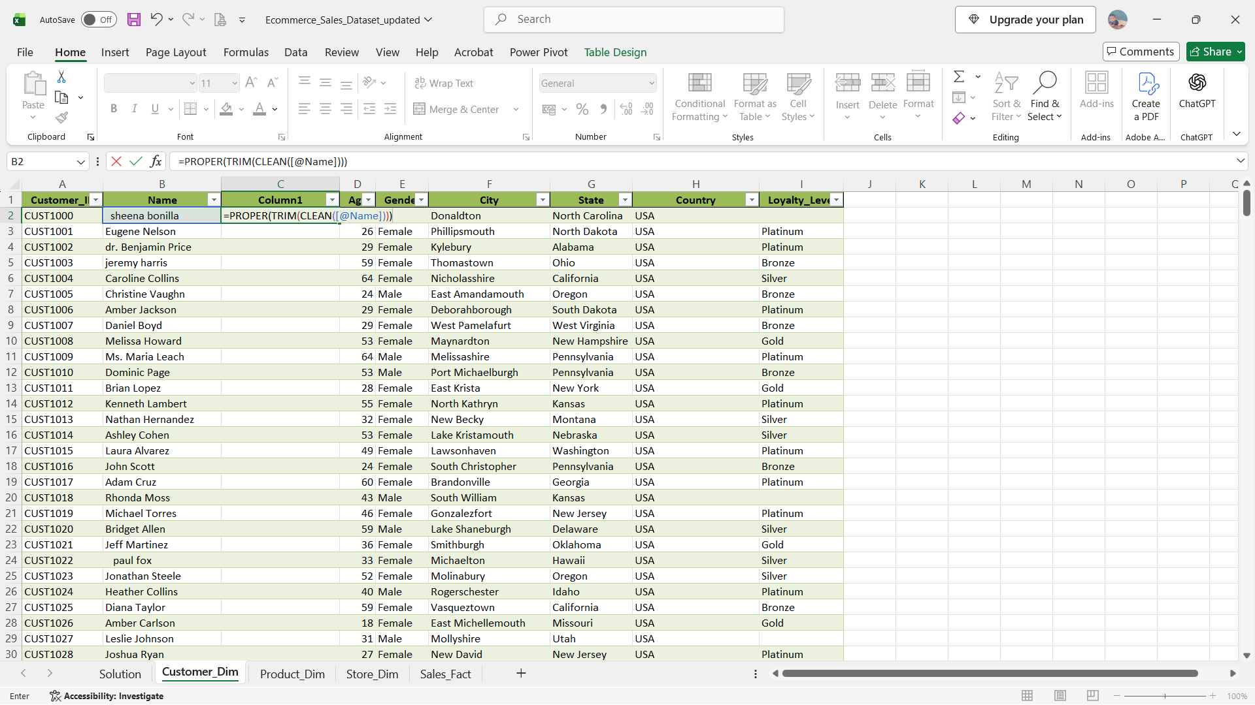

=IF(OR(ISBLANK([@Loyalty_Level]),[@[Loyalty_Level]]=0),”Unknown”,[@[Loyalty_Level]])

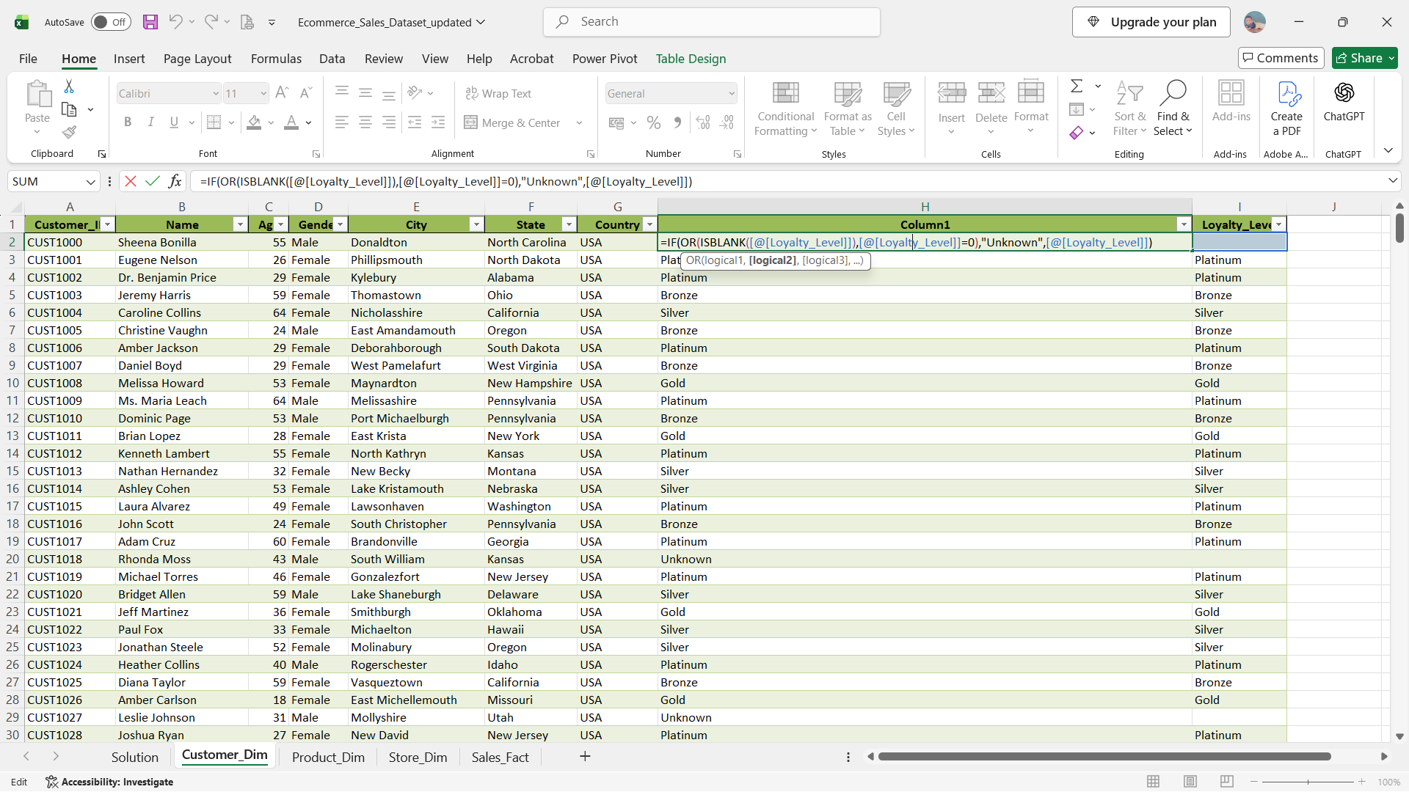
Handling Duplicate Values
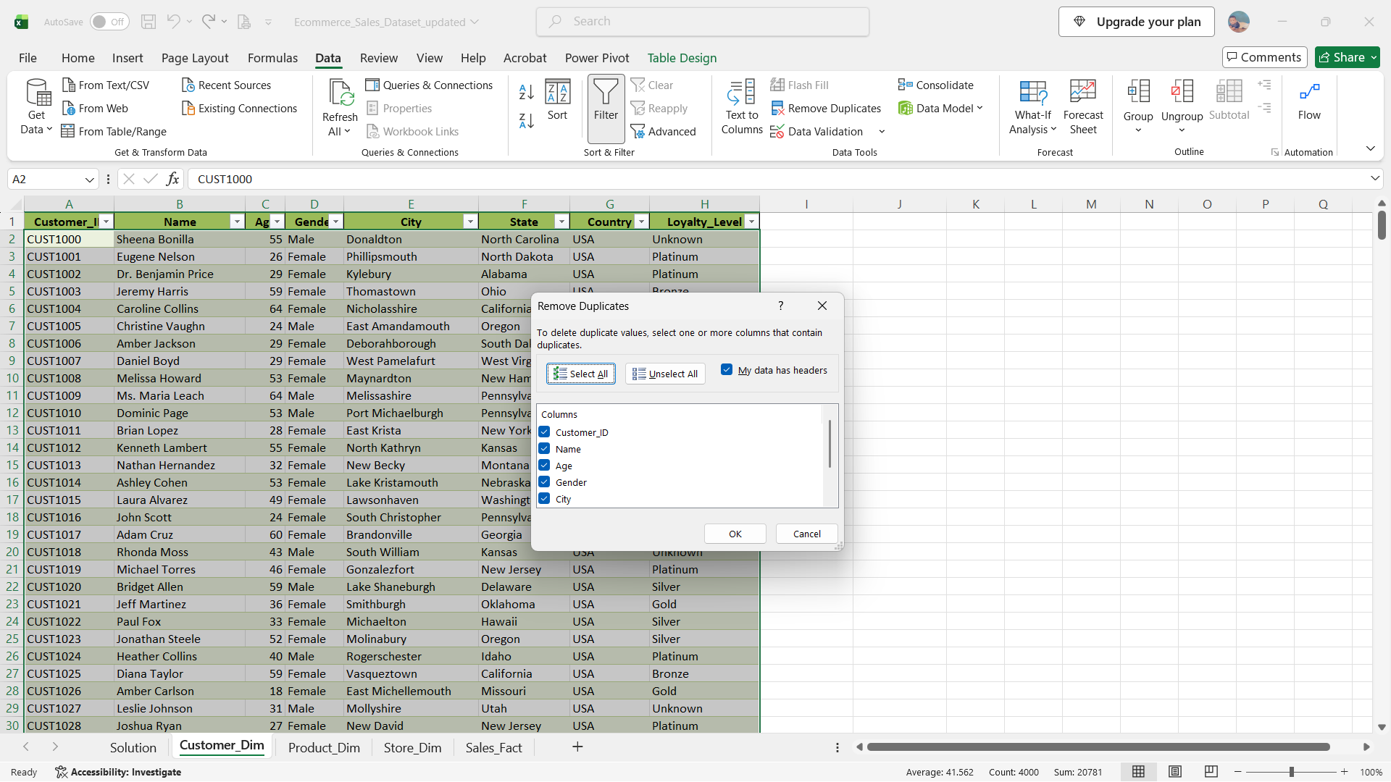

Finding the missing values using formulas

unit price = (Tot amt/(qty*(1-Discount))) |  |  | OR |  | We can take the average of the individual product id's
Tot Amt = Qty*Unit Price*(1-Discount) |  |  |  |  | For example, the average unit price of PROD60 is $398.886
Grs Amt = Qty*Unit Price |  |  |  |  | For Qty we can take the average of the Total Qty Product wise using pivot table and xlookup
Discount % = (Grs Amt − Total Amt) ÷ Grs Amt × 100 |  |  |  |  | Discount values is replaced with Zero

=IF(OR(ISBLANK([@Quantity]),[@Quantity]=0),AVERAGE([Quantity]),[@[Quantity])
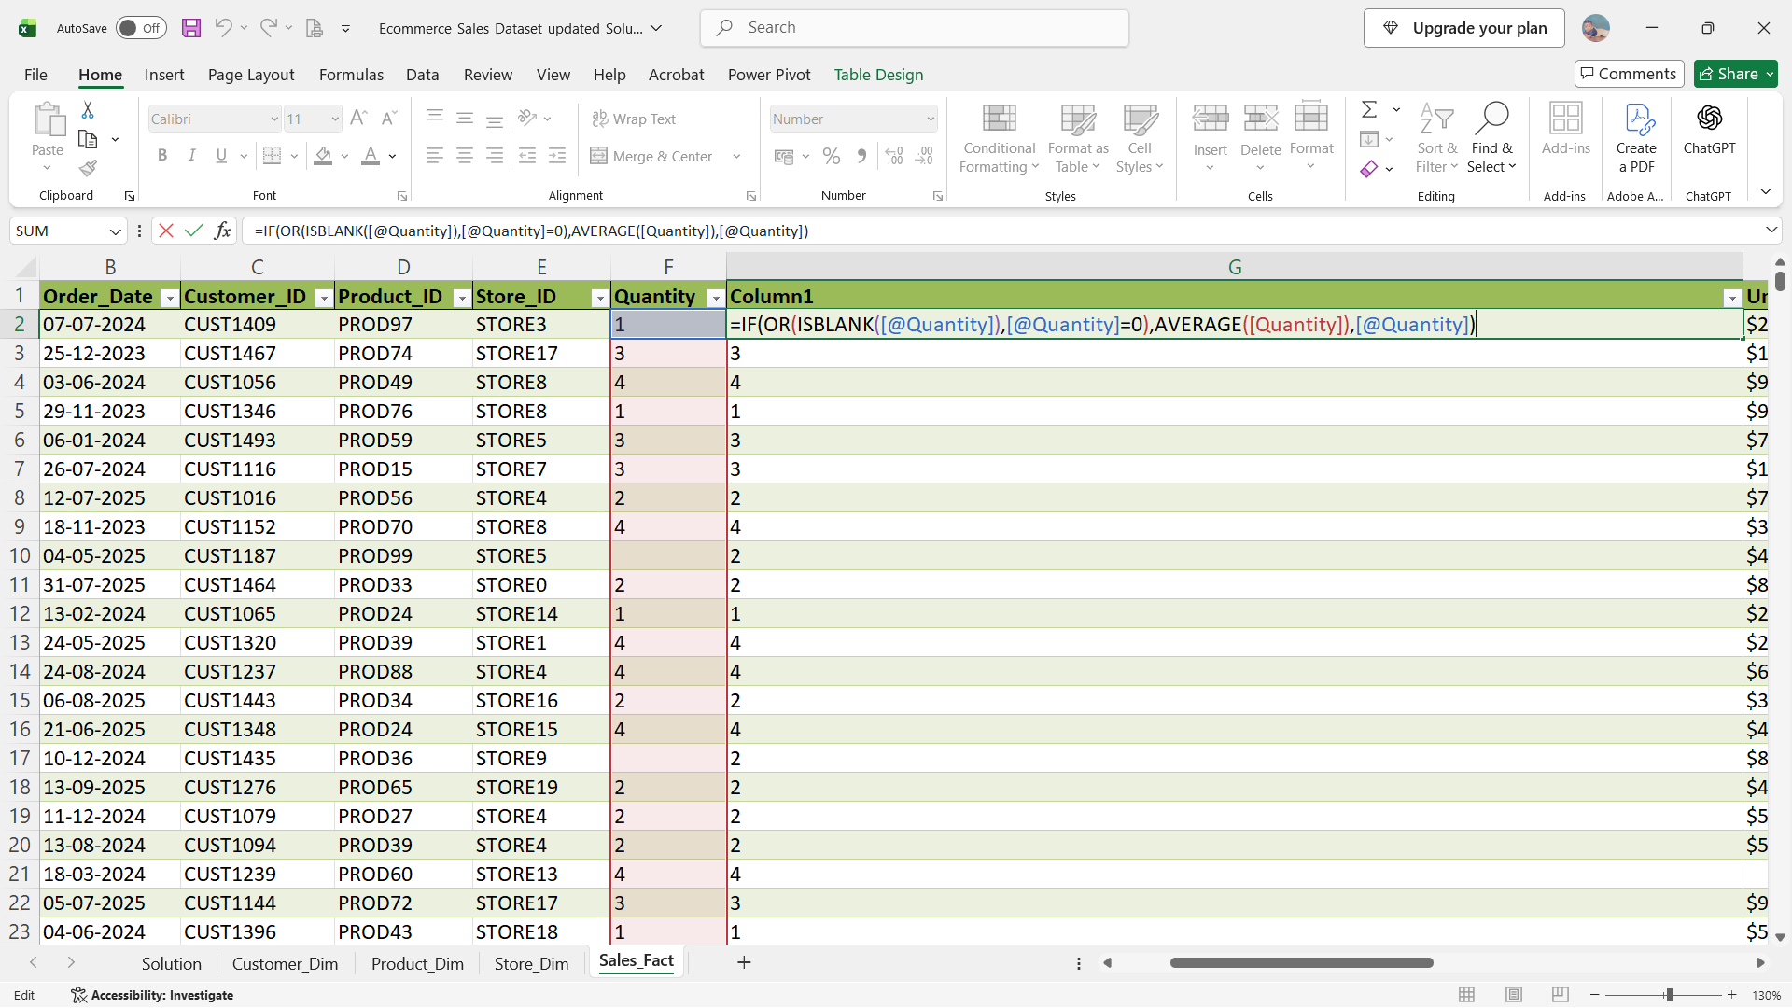

Using Pivot create a table to find the average unit price of all the product id’s, and use Xlookup to find the missing unit price.

=IF(ISBLANK([@[Unit_Price]]),XLOOKUP([@[Product_ID]],M3:M102,N3:N102,NA,0),[@[Unit_Price]])

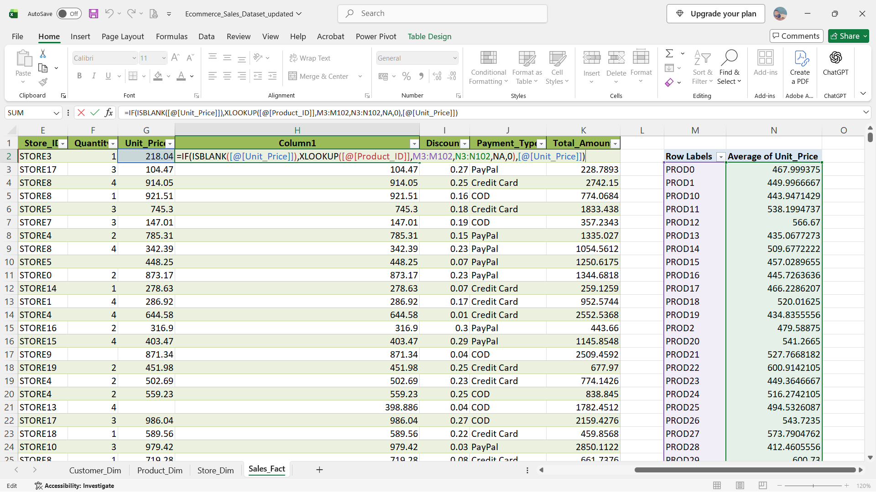
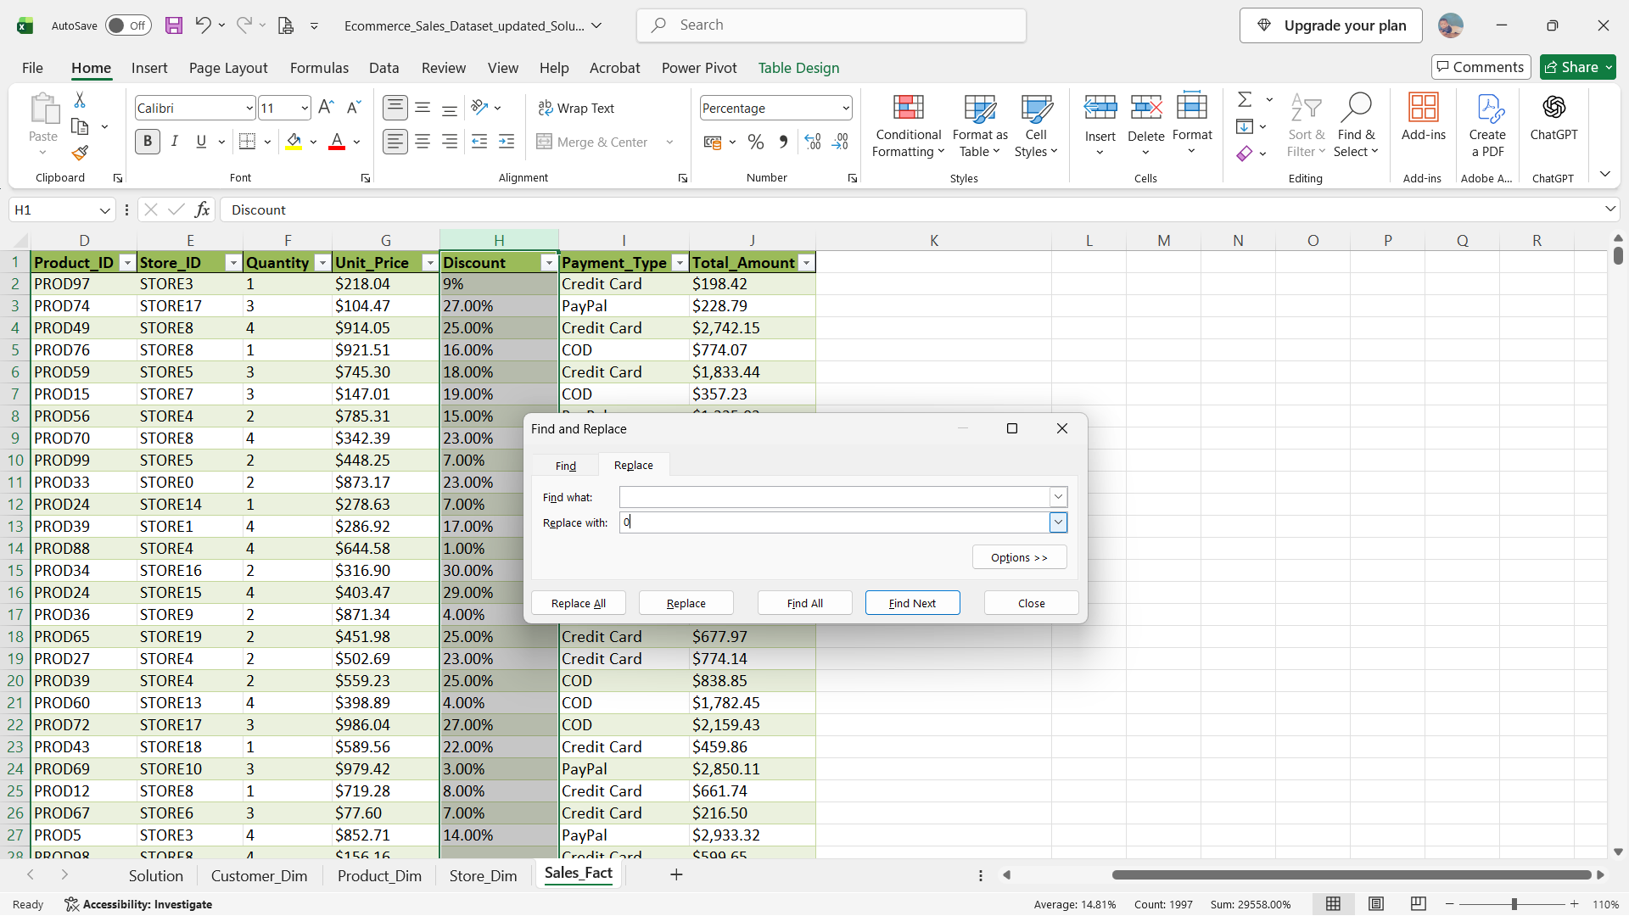
Using a formula to calculate the Total Amount

=[@Quantity]*[@[Unit_Price]]*(1-[@Discount])

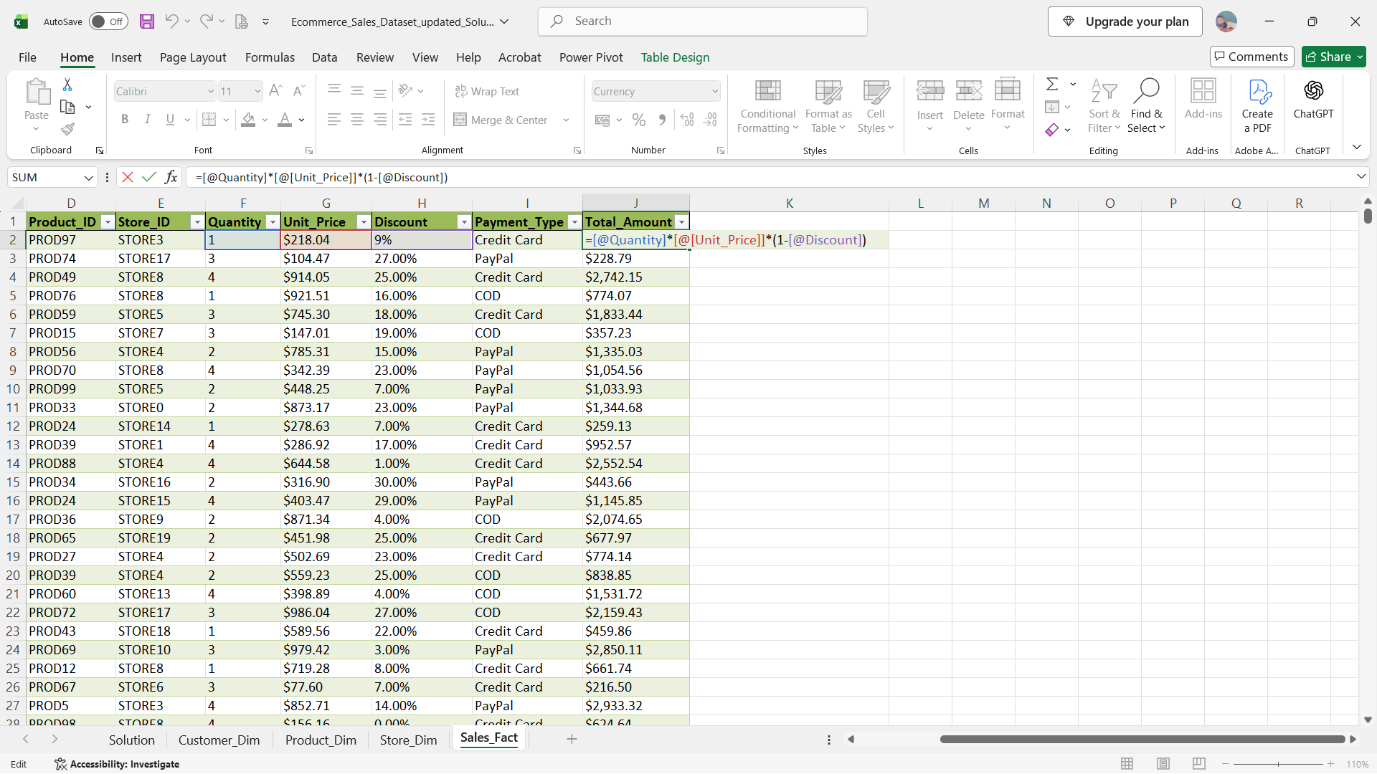

Used Text function to split the date into Month & Year

=TEXT([@[Order_Date]],” MMM YYY”)
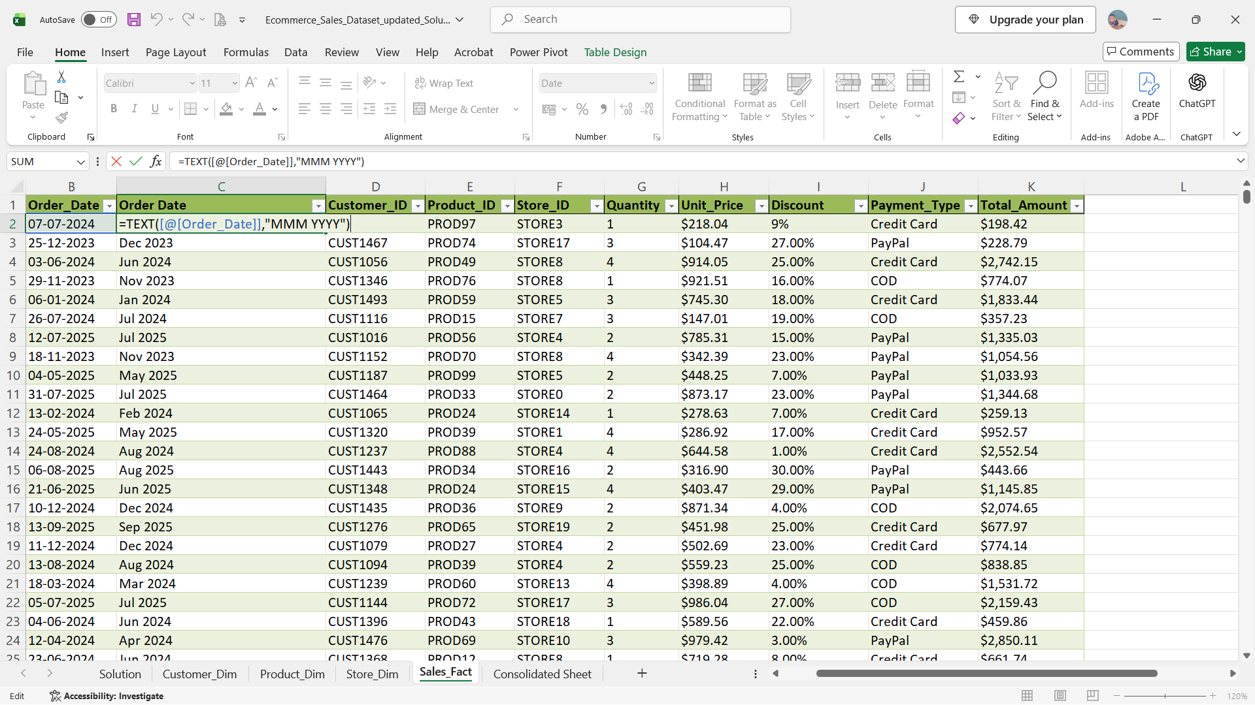
Used Vlookup to combine sheets using Cust ID, Prod ID, Store ID into the Sales_Sheet

=VLOOKUP([@[Product_ID]],Product_Dim!A:C,3,0)

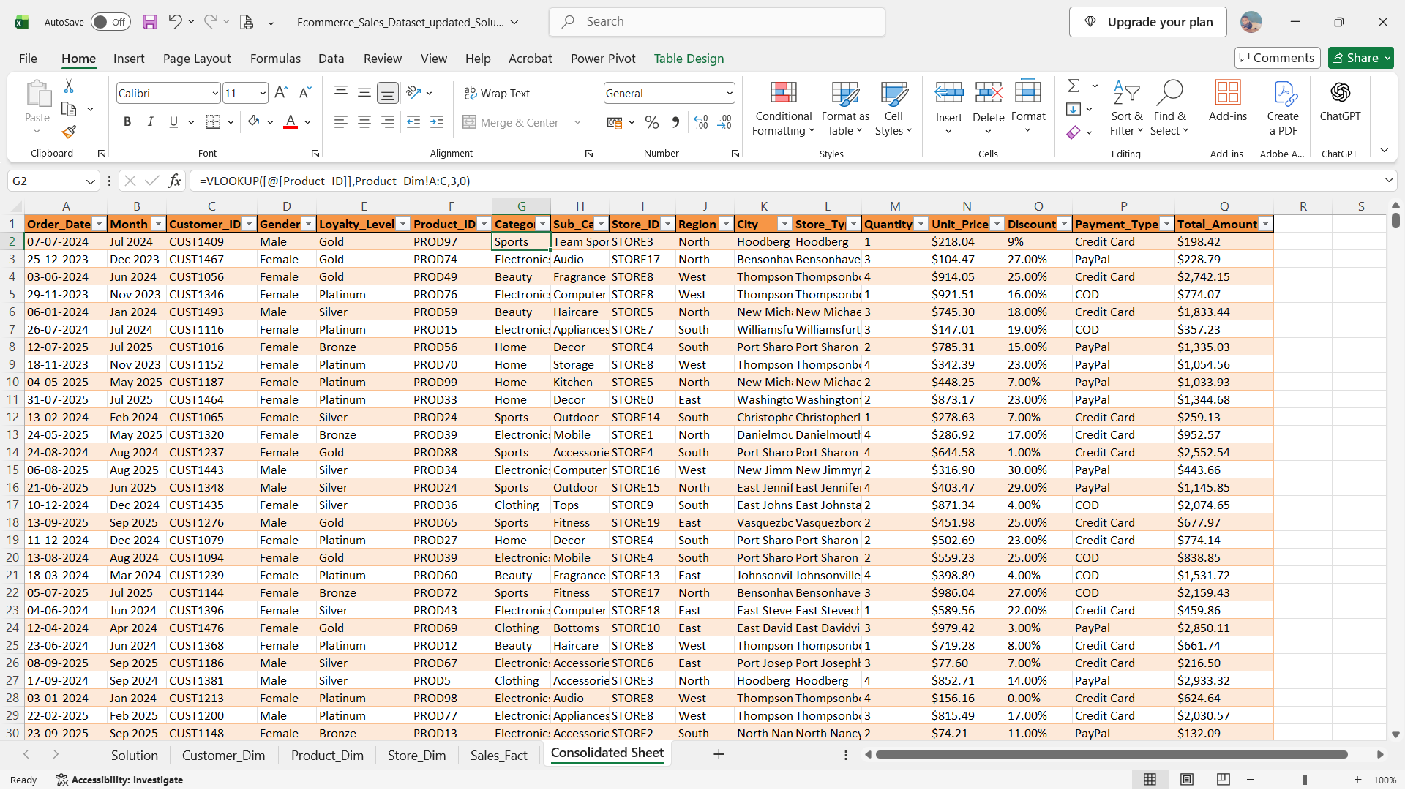

Used Descriptive Statistics using Toolpak
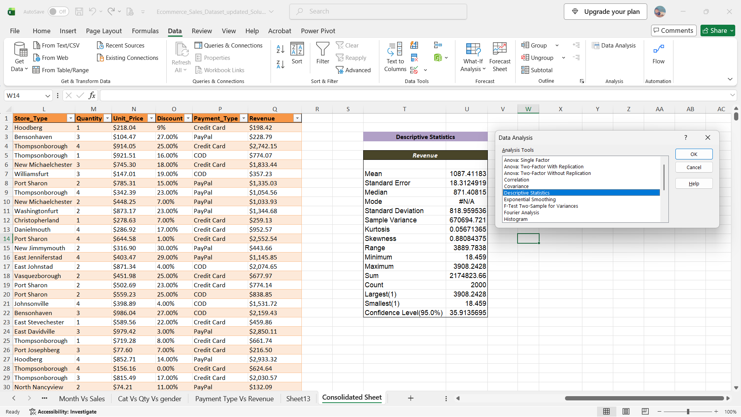
Visualization and Insights Arrived with screenshot of visualization
Report/Dashboard screenshot:

- Descriptive analysis:
  - What is the total sales?
  - Which product category generated the highest sales?
  - Which region performed best?
  - Which Year had the highest sales?
- Diagnostic Analysis:
  - Why did the top category generate higher sales?
  - Why is the profit higher/lower for certain products?
- Predictive Analysis:
  - Based on the sales trend, what could next month's sales be?
  - Which category is likely to perform well in the future?
- Prescriptive Analysis:
  - Which category should the company focus on?
  - Should the company increase or reduce discounts?
  - What 3 actions should the company take to improve profit?

Dashboard Image:

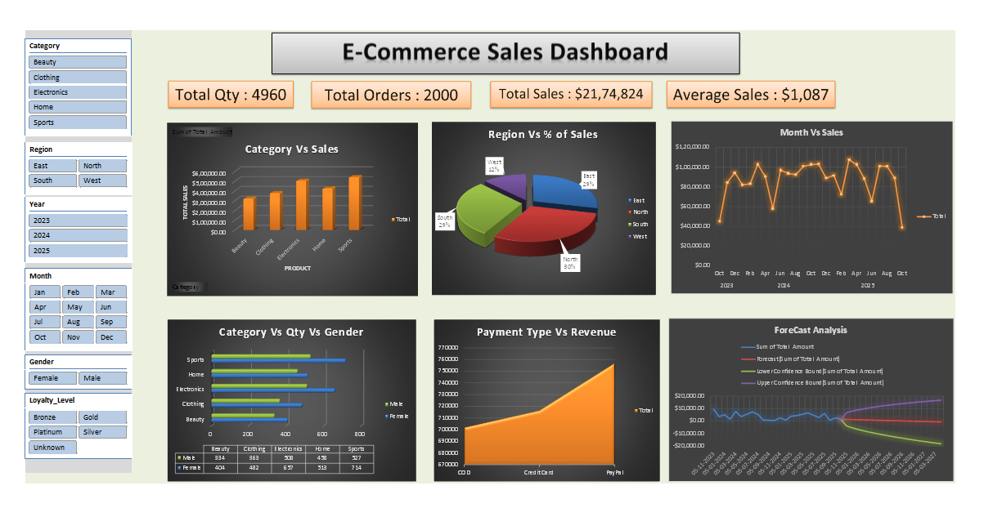

Final 4 type of insights as storytelling:

We had 2,000 total orders placed by happy customers. Together, they bought 4,960 total items. Our total sales revenue came out to $21,74,824, and the average order was about $1,087. Out of all our product categories, Sports brought in the most money, closely followed by Home and Electronics. I noticed that Sports and Home did so well because both male and female customers bought them in steady, balanced quantities. When people paid for their items, most of them used Credit Cards and PayPal, which made transactions smooth and easy compared to cash-on-delivery. The trend lines show that our upcoming monthly sales will likely settle comfortably between $10,000 and $15,000 as regular seasonal cycles continue. Electronics and Sports look like they will keep growing and remain customer favorites. Put more advertising and stock into our top-selling categories like Sports and Home. Instead of giving giant percentage discounts that cut into our profits, we should try offering bundle deals. Our West region only has 12% of sales, so we should run special promos there to catch up with the North and East.

Conclusion:
This project taught me that data isn't just a scary spreadsheet, it is actually a story about people shopping, buying, and helping a business grow. I am so proud of building my first dashboard and finding these insights.

